Frank Murgolo leaving Dive Catalina with excited Introductory Divers



GEAR RENTAL

Couple enjoying a day at Avalon Dive Park with Dive Catalina gear rental

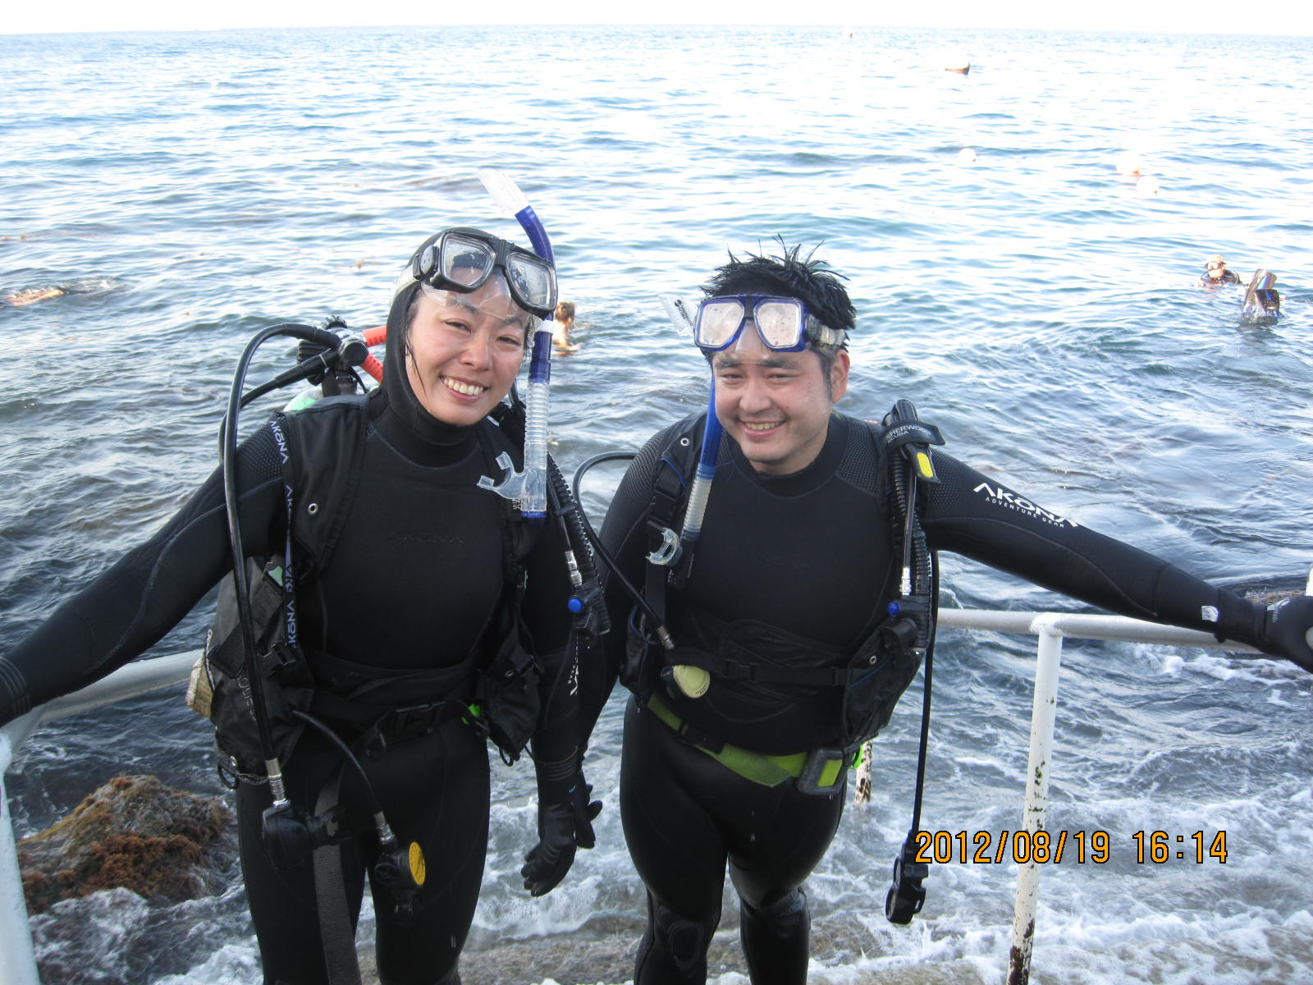

Cruise Ship Certified Divers with DC RENTAL GEAR (Avalon Dive Park)

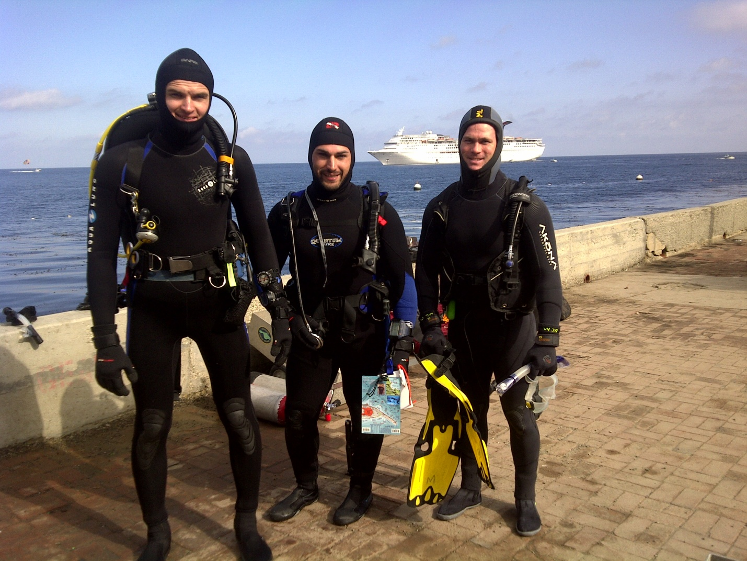

CERTIFIED DIVERS ENJOYING AFTERNOON AT AVALON DIVE PARK WITH DC RENTAL GEAR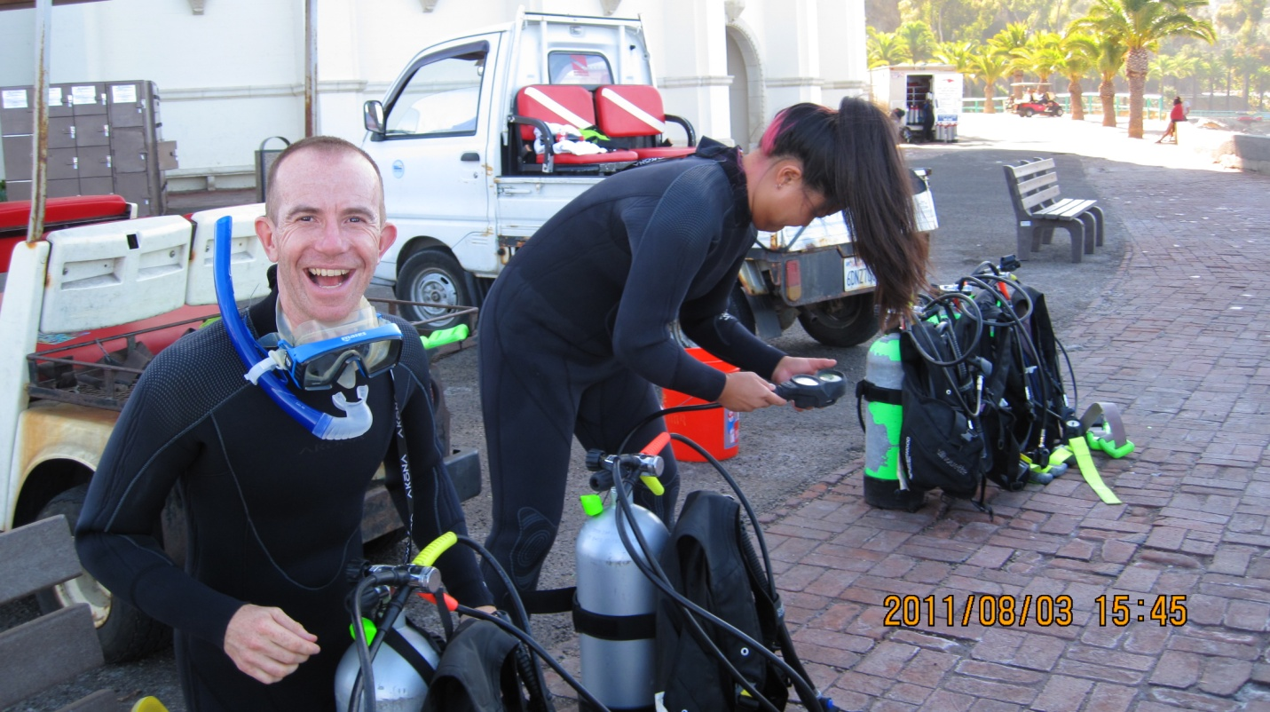

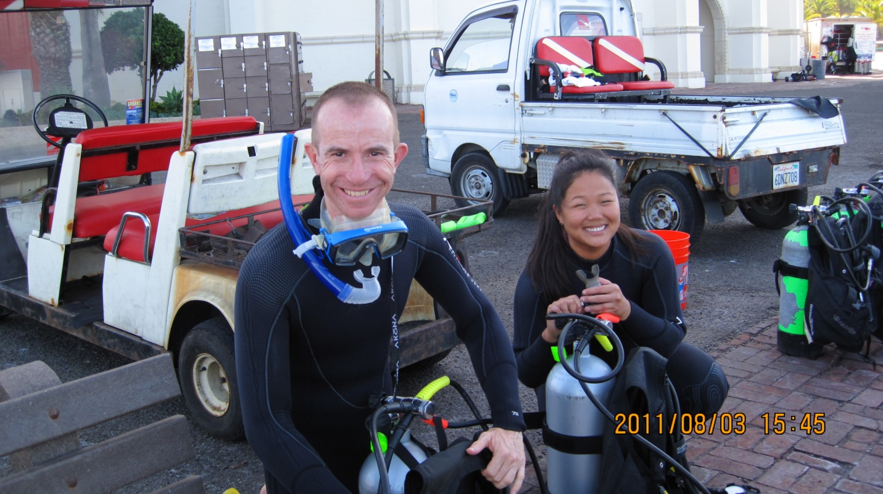

Getting ready for a guided night dive

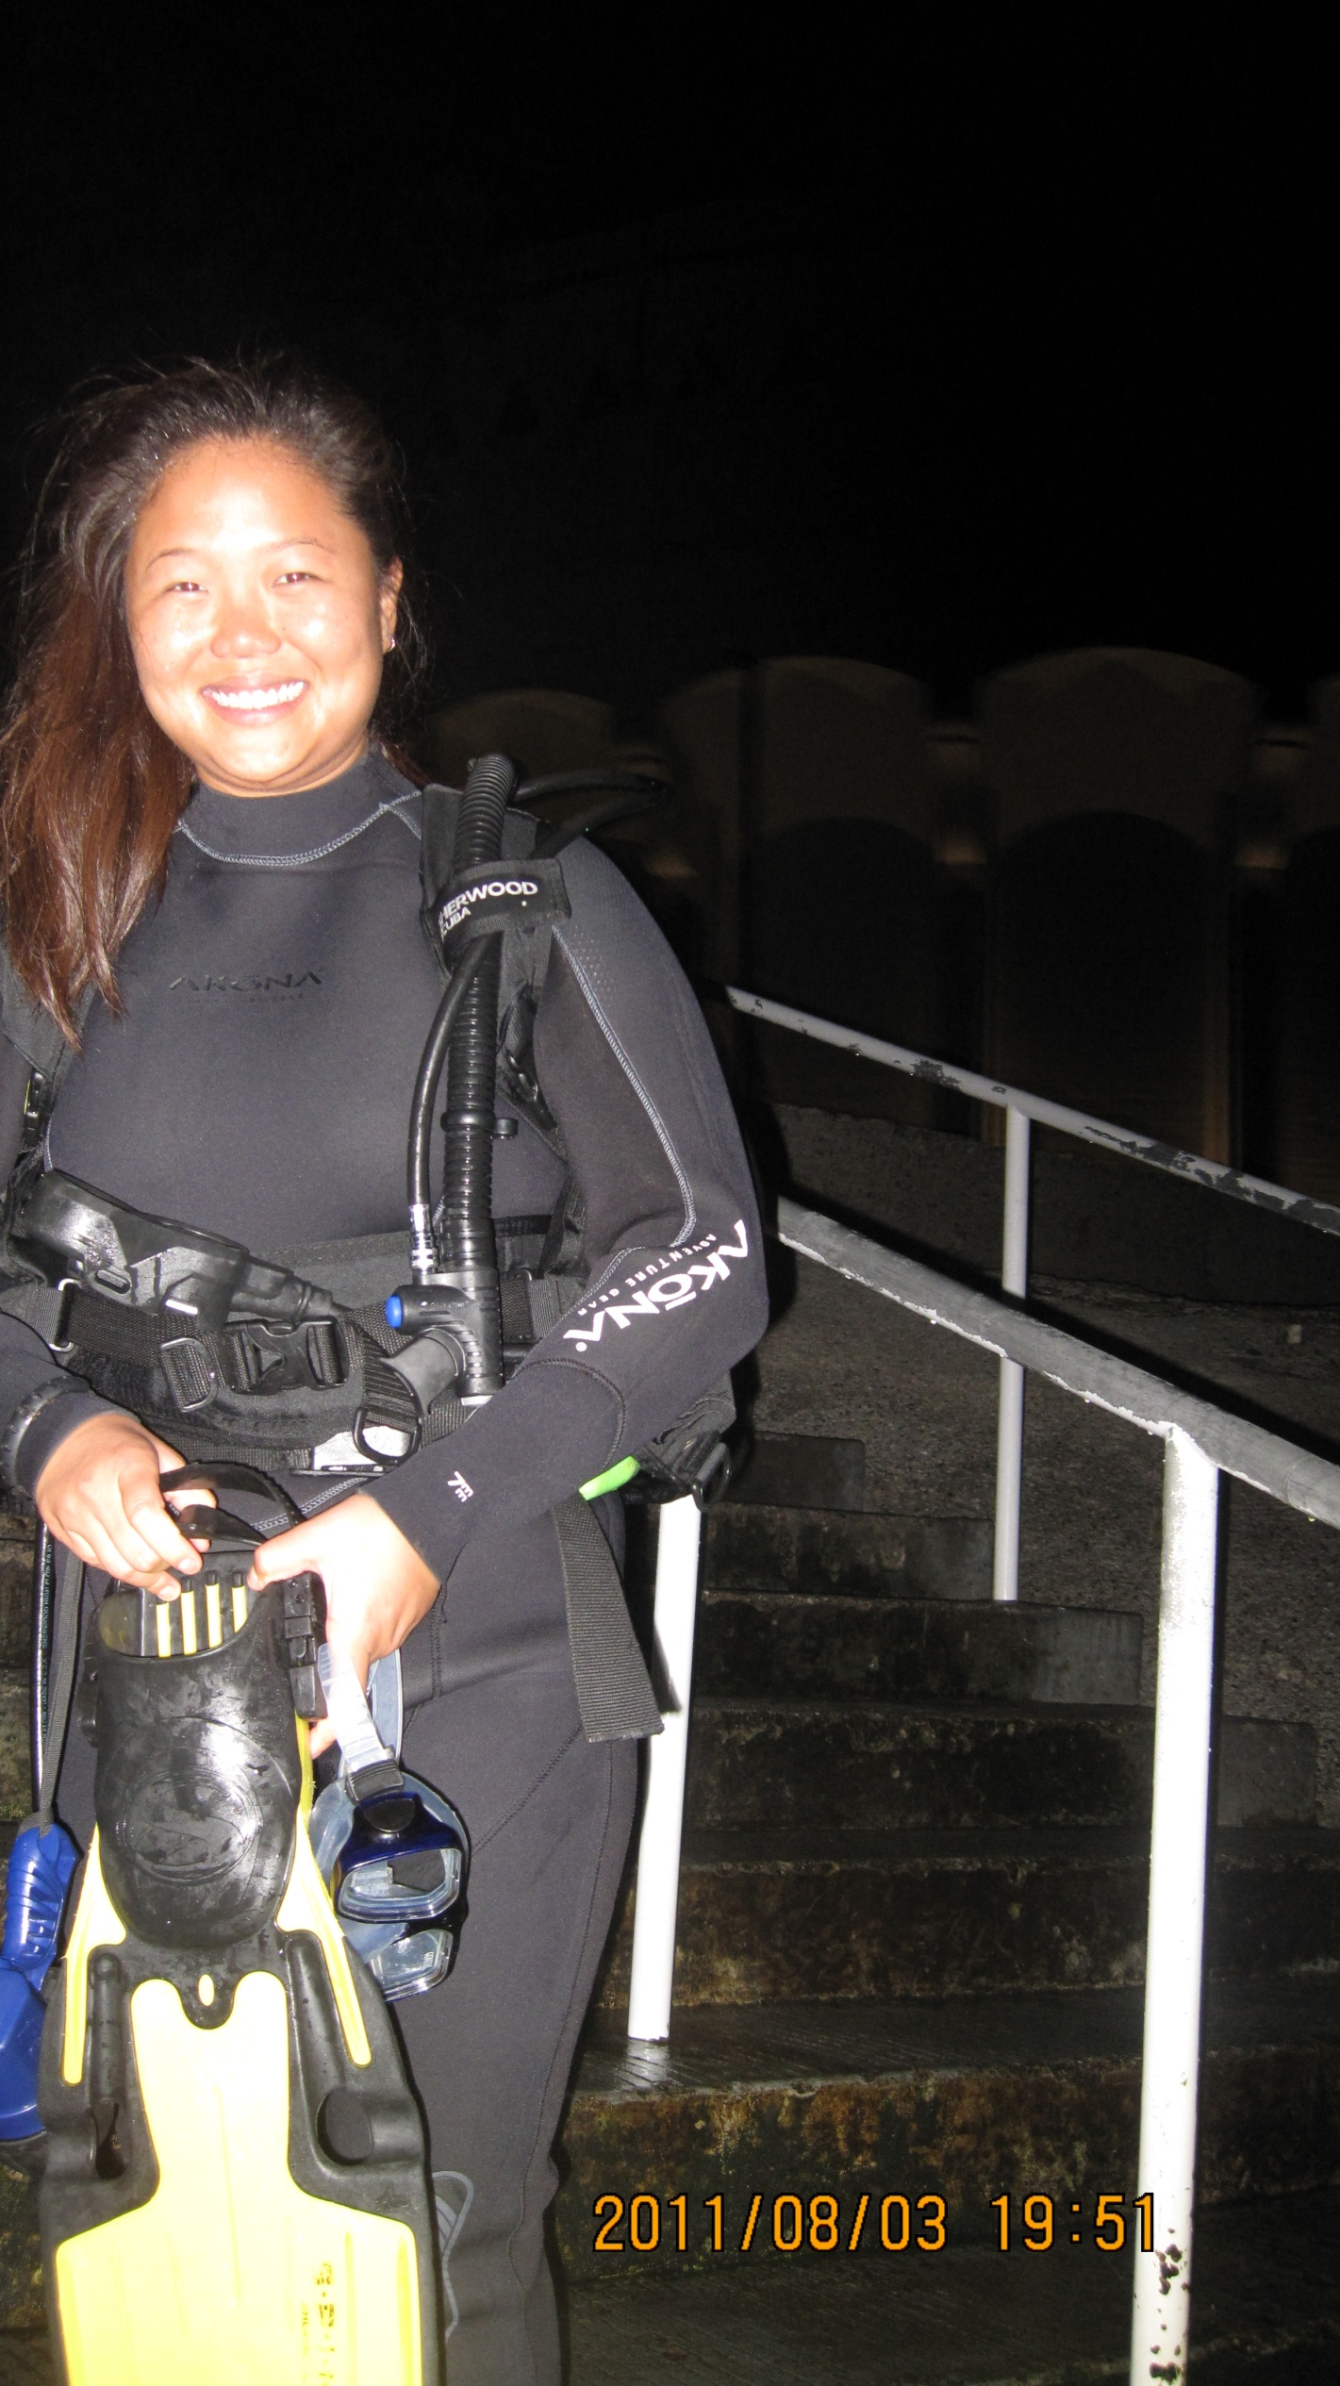

Night dive at Avalon Dive Park (Guided)

